***MD NOWSHAD UL ALAM***

SQL STATEMENTS

DATA Definition Language (DDL)

***QUERIES TABLES***

create table BranchOffice(

BranchNo int Primary key not null,

Branchcity nvarchar(50) not null,

Branchstreet nvarchar(50),

Branchpostcode int ,

BranchTelephoneNumber int not null,

)

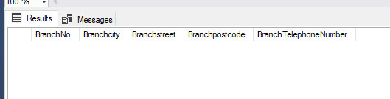

create table employee

(

EmployeeId int Primary Key,

EmployeeName nvarchar(50) not null,

EmployeeAddress nvarchar(50),

EmployeePosition nvarchar(50),

EmployeeSallary int ,

)

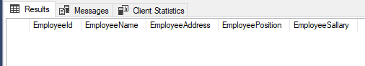

create table property

(

PropertyId int primary key not null,

Propertystreet nvarchar(50),

Propertycity nvarchar(50) not null,

Propertypostcode int

)



create table privateowner(

privateownerId int primary key,

privateownerName nvarchar(50),

privateownerAddress nvarchar(50),

privateownertelephonenum int ,

privateowneremailaddress nvarchar(50),

privateownerpassword nvarchar(50),

)

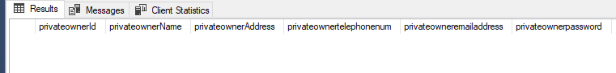

create table businessowner(

businessownerId int primary key,­­

businesseownerName nvarchar(50),

businesstype nvarchar(50),

businessownerAddress nvarchar(50),

businessownertelephonenum int ,

businessowneremailaddress nvarchar(50),

businessownerpassword nvarchar(50),

)

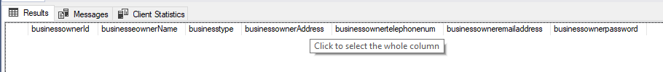

create table client

(

clientId int primary key,

clientname nvarchar(50),

clienttelephonenum nvarchar(50),

clientaddress nvarchar (50),

clientemail nvarchar(50),

)

